Time series Model

Rolling mean and standard deviation

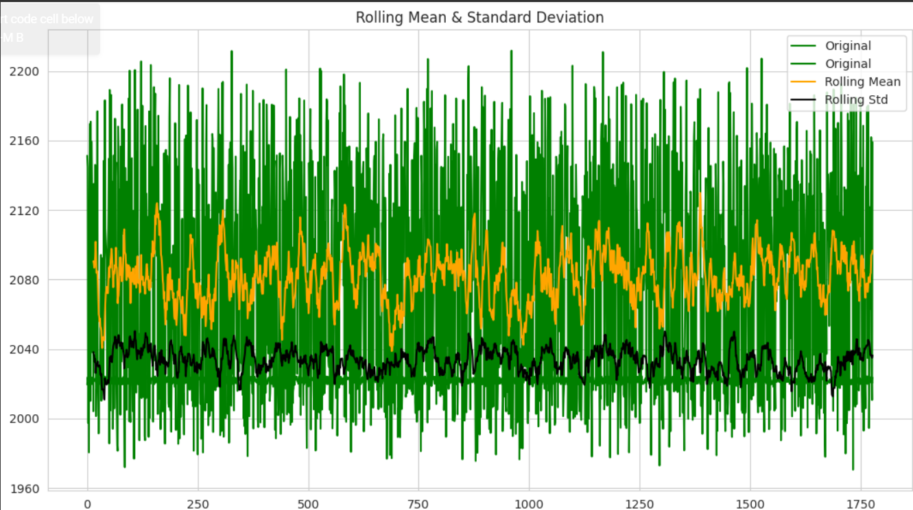

OUTPUT for next 7 days: from may 1 – may 7 2024

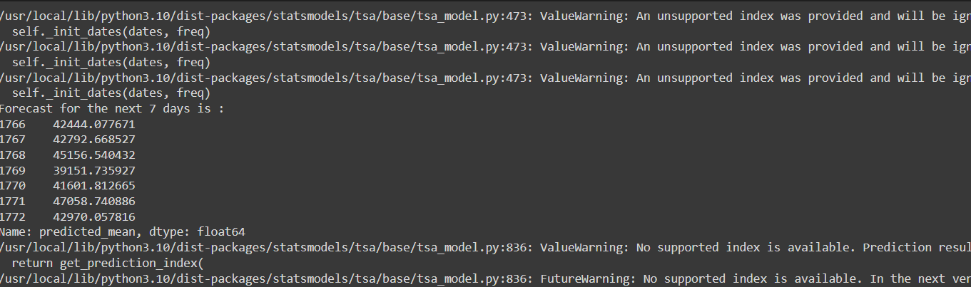

The model performs well and good and had conducted dickey fuller test to know its evaluation score.